

Pupil Premium Strategy Statement

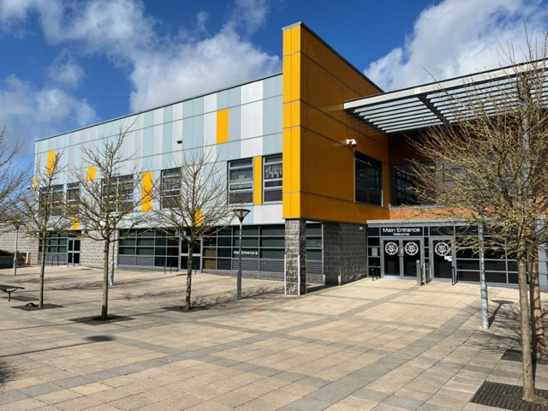

Pupil premium strategy statement – Broadfield Specialist School

This statement details our school’s use of pupil premium (and recovery premium) funding to help improve the attainment of our disadvantaged pupils.

It outlines our pupil premium strategy, how we intend to spend the funding in this academic year and outcomes for disadvantaged pupils last academic year.

School overview
Detail | Data
Number of pupils in school | 191
Proportion (%) of pupil premium eligible pupils | 44%
Academic year/years that our current pupil premium strategy plan covers | 2022/2023  to 2025/2026
Date this statement was published | December 2022
Date on which it will be reviewed | December 2023
Statement authorised by | Angela Wade, Headteacher
Pupil premium leads | Angela Wade, Headteacher  Louise Preston, Strategic Data Coordinator  Anna Pye, Extended Services
Governor / Trustee lead | Julie Darwin

Funding overview
Detail | Amount
Pupil premium funding allocation this academic year | £72,684
Recovery premium funding allocation this academic year | £45,335
Pupil premium (and recovery premium) funding carried forward from previous years | £0
Total budget for this academic year | £118,019

Part A: Pupil premium strategy plan

Statement of intent
- We ensure quality first teaching across school, so that all students make good progress or better. As all our students have special educational needs, their learning needs are a greater barrier to achievement than their socio-economic background. Due to our highly specialised and experienced staff, we do not have an attainment gap in academic subjects between disadvantaged students and their peers. Therefore, our priority is to address the wider needs of our students through a holistic approach, whilst providing academic interventions to any students who require them.
- We support our students’ development by addressing their emotional and physical wellbeing. Our disadvantaged students particularly show a high level of persistent absenteeism due to social anxiety and emotionally based school anxiety.
- We broaden the Cultural Capital of disadvantaged students by providing a range of experiences to increase their cultural awareness, knowledge and competence.
- We aim to develop important life skills for all our students. However, our data shows that disadvantaged students require a more tailored and individualised approach to support them to increase their independence.

Challenges
This section details the key challenges to achievement that we have identified among our disadvantaged pupils.
Challenge number | Detail of challenge
1 | Our attendance data over the last 2 years shows that attendance has been low for many students, with many disadvantaged students having significantly lower attendance. Many students have medical needs that further impact on attendance. Some disadvantaged students have struggled to return to full attendance following lockdowns, due to emotionally based school anxiety.  38% of disadvantaged students have been ‘persistently absent’ during this period. Our assessments and observations indicate that absenteeism is negatively impacting disadvantaged students’ progress.
2 | Our assessments (including wellbeing survey), observations and discussions with students and families have identified social and emotional issues for many students, such as anxiety, depression (diagnosed by medical professionals) and low self-esteem. These challenges particularly affect disadvantaged students, including their attainment.  Teacher referrals for support remain high. 44 disadvantaged students currently require additional support with social and emotional needs and receive individual or small group interventions.
3 | Our observations and discussions with students and families show many disadvantaged students are subject to a loss of opportunities due to the current cost of living crisis. This particularly impacts on cultural capital and the ability for those families to interact with their communities and take part in activities in the local area. There is also an impact on those parents ability to engage with school, due to financial restraints and poor mental health. Our parents require support from specialist staff to help them understand how to continue strategies used in school to help at home.
4 | Our assessments and observations of students has shown that many disadvantaged students show poorer physical health than the general school population. This is further impacted on by the restrictions some of those students have due to physical disabilities. Many of our students are unable to take part in sporting activities in the community due to lack of facilities and access to changing/toileting.
5 | Our assessments, observations and discussions with students and their families have identified that many of our students have poor life skills. This is particularly the case for disadvantaged students. Parents struggle to demonstrate these skills in the home environment.

Intended outcomes
This explains the outcomes we are aiming for by the end of our current strategy plan, and how we will measure whether they have been achieved.
Intended outcome | Success criteria
To achieve and sustain improved attendance for all students, particularly our disadvantaged students. | Sustained improved attendance by 2024/25 demonstrated by:  - The overall unauthorised absence rate for all students being no more than 2%.  - The percentage of all students who are persistently absent being below 5%.
To achieve and sustain improved wellbeing for all students, including those who are disadvantaged. | Sustained higher levels of wellbeing by 2024/25 demonstrated by:  - Qualitative data from student voice, student and parent surveys and teacher observations.  - A significant increase in participation in extra-curricular activities, particularly among disadvantaged students.
To achieve and sustain improved engagement with parents and carers, particularly those families who are disadvantaged. | Higher parental engagement demonstrated by:  - Improved attendance at school events, including student achievement days, drop in sessions with parent liaison and parent workshops with specialist staff.  - Improved satisfaction on parent surveys.
To achieve and sustain improved student engagement in extra-curricular and sporting activities. | - Sustained improved attendance for disadvantaged students in clubs and activities.  - In-school assessment data showing an increase in attainment for health and wellbeing.
To achieve and sustain improved levels of life skills for all students, particularly our disadvantaged students. | - Sustained improved attainment for students shown in in-school assessment data for a range of life skills.  - Achieved outcomes in students’ EHCPs

Activity in this academic year
This details how we intend to spend our pupil premium (and recovery premium funding) this academic year to address the challenges listed above.

Teaching (for example, CPD, recruitment and retention)
Budgeted cost: £17,706
Activity | Evidence that supports this approach | Challenge number(s) addressed
Staff CPD on mental health and wellbeing | “The effects of high-quality professional development on teachers and students” (2020)  https://epi.org.uk/publications-and-research/effects-high-quality-professional-development/  EEF – Effective professional development  https://educationendowmentfoundation.org.uk/education-evidence/guidance-reports/effective-professional-development | 2,3
Parent workshops | https://educationendowmentfoundation.org.uk/education-evidence/teaching-learning-toolkit/parental-engagement | 2,3,4,5
PPG coordinator | We have found in our setting, a coordinator role leads to a more streamlined response to the needs of our disadvantaged students. | 1,2,3,4,5

Targeted academic support (for example, tutoring, one-to-one support structured interventions)
Budgeted cost: £94,688
Activity | Evidence that supports this approach | Challenge number(s) addressed
Targeted interventions – ELSA, SALT, play therapy, wellbeing, behaviour | https://educationendowmentfoundation.org.uk/education-evidence/teaching-learning-toolkit/social-and-emotional-learning  https://educationendowmentfoundation.org.uk/education-evidence/teaching-learning-toolkit/behaviour-interventions  https://educationendowmentfoundation.org.uk/education-evidence/teaching-learning-toolkit/oral-language-interventions | 2,4,5
Equine therapy | https://www.therapywithhorses.co.uk/evidence-based-research/  https://s3.wp.wsu.edu/uploads/sites/609/2014/04/effects-of-equine-facilitated-learning.pdf | 2,4

Wider strategies (for example, related to attendance, behaviour, wellbeing)
Budgeted cost: £5,814
Activity | Evidence that supports this approach | Challenge number(s) addressed
Parent liaison | https://educationendowmentfoundation.org.uk/education-evidence/teaching-learning-toolkit/parental-engagement | 1,3
Breakfast club/ free toast at break time | https://educationendowmentfoundation.org.uk/news/breakfast-clubs-found-to-boost-primary-pupils-reading-writing-and-maths-res  https://educationhub.blog.gov.uk/2022/11/24/how-we-are-ensuring-thousands-of-children-receive-a-healthy-nutritious-breakfast/ | 4
After-school/Saturday/Holiday clubs | https://educationendowmentfoundation.org.uk/education-evidence/teaching-learning-toolkit/arts-participation | 2,3
Residentials | https://naee.org.uk/impacts-benefits-residential-experience/  https://educationendowmentfoundation.org.uk/education-evidence/teaching-learning-toolkit/outdoor-adventure-learning | 2,3,4,5
Furnishing independent living rooms | UK government report:  https://assets.publishing.service.gov.uk/government/uploads/system/uploads/attachment_data/file/942557/ELS_Process_Evaluation.pdf | 5

Total budgeted cost: £118,208

Part B: Review of the previous academic year

Outcomes for disadvantaged pupils

Absence among disadvantaged pupils was X% higher than their peers in 2021/22 and persistent absence X% higher. We recognise this gap is too large which is why raising the attendance of our disadvantaged pupils is a focus of our current plan.

English Attainment:
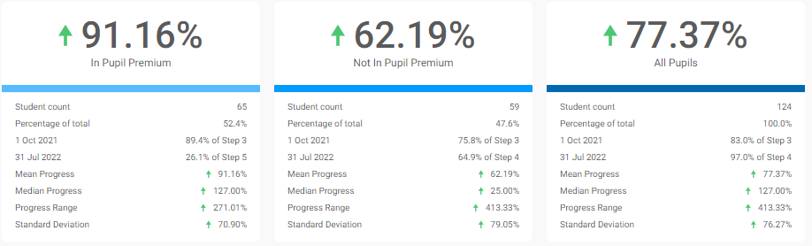
Maths Attainment:
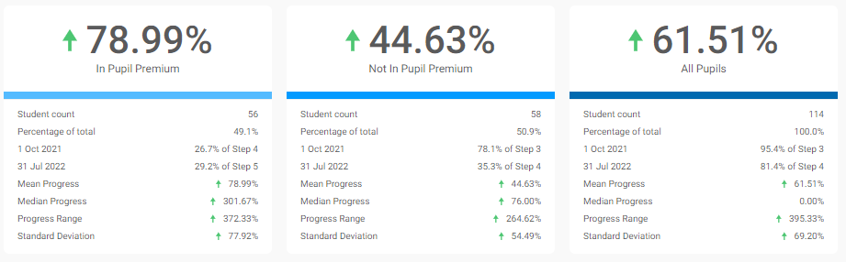

PSHCE Attainment:
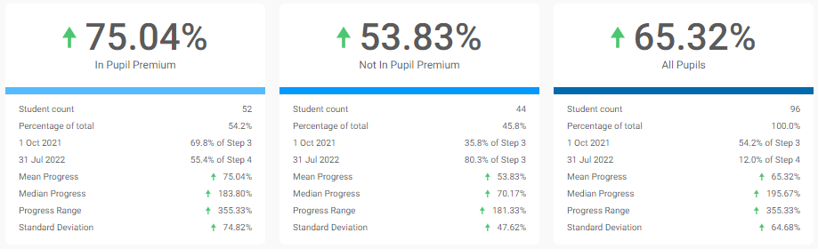

Externally provided programmes
Programme | Provider

Further information (optional)
Additional activity
Our pupil premium strategy will be supplemented by additional activity that is not being funded by pupil premium or recovery premium. This will include:
- Holiday and Saturday clubs, funded by Lancashire Breaktime Services.
- As costs outweigh the funding received through Pupil Premium and Recovery Premium, some associated costs will be met through the school budget.

Planning, implementation, and evaluation
In reviewing our current pupil premium strategy, we evaluated which activities undertaken in the previous year had not had the degree of impact that we had expected.
We triangulated evidence from multiple sources of data including exams and assessments, engagement in class book scrutiny, and conversations with parents, students and staff in order to identify the challenges faced by disadvantaged pupils.
We looked at a number of reports and studies about effective use of pupil premium, the impact of disadvantage on education outcomes and how to address challenges to learning presented by socio-economic disadvantage. We also looked at a number of studies about the impact of the pandemic on disadvantaged pupils.
We used the EEF’s implementation guidance to help us develop our strategy and will continue to use it through the implementation of our activities.
We have implemented a robust evaluation framework for the duration of our three-year strategy and will adjust our plan over time to secure better outcomes for pupils.

