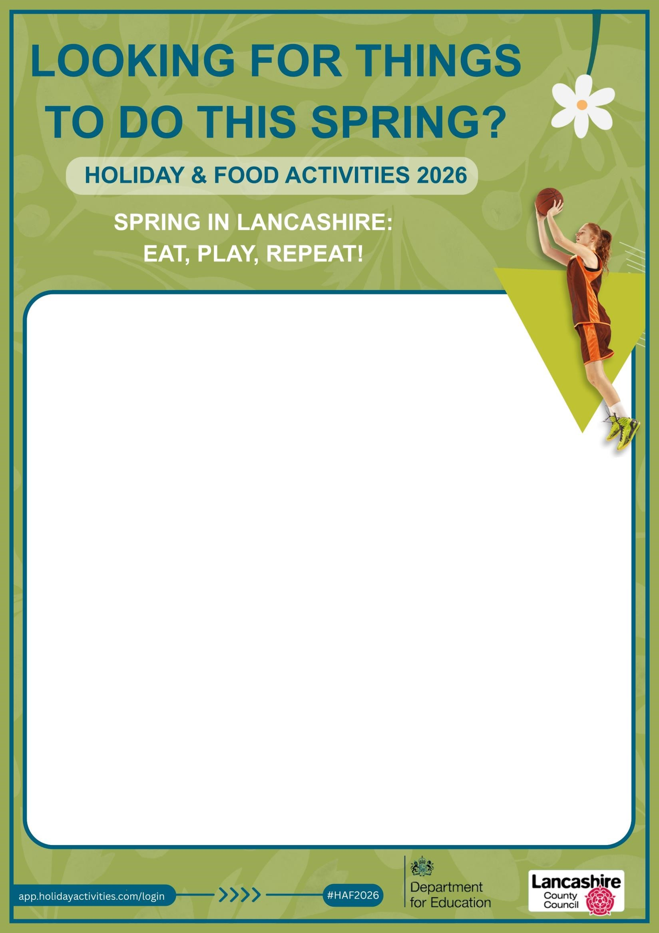

Targeted Youth Service – Burnley
Tuesday 7th April 2:00pm – 6:00pm – The Easter Trail – Townley Park Burnley
Get ready for an action-packed outdoor adventure this Easter! Young people to meet at Townley Park for the activity which is open to young people aged 11 to 16 who are attending secondary school. Participants will take part in an exciting orienteering challenge, using maps and teamwork to navigate their way around the course and complete checkpoints. Along the way, teams will face fun problem solving and physical challenges to earn materials and items they’ll need for the final task — the Egg Drop Challenge! Using everything they’ve won, teams must design and build a structure to protect their egg from a drop… will it survive? There will be prizes to win, including Easter eggs, and food will be provided for all participants.

Wednesday 8th April 6:00pm till 10:00pm – UV Sports and Games – Burnley Zone
Get ready for a high-energy UV Party and Sports Night this Easter! This activity is open to young people aged 11 to 16 who are attending secondary school. Participants will enjoy a vibrant UV party atmosphere, with glowing lights and music, alongside a range of UV-themed sports activities, including UV dodgeball and UV cricket, where equipment and playing areas will glow under the lights for an extra fun twist. Whether you’re getting competitive or just playing for fun, there’s something for everyone. Food will be provided for all participants, making it a brilliant opportunity to get active, socialise, and enjoy a safe, supervised night of UV fun.

Thursday 9th April 6:00pm till 10:00pm – Stoneyholme & Daneshouse Inflatable Sports
Get ready for a high-energy Inflatable Sports Session packed with fun and excitement! Young people to meet at Stoneyholme & Daneshouse for the activity which is open to young people aged 11 to 16 who are attending secondary school. Participants will have the chance to take part in a range of inflatable sports activities, including inflatable sumo wrestling, inflatable archery, and inflatable football. Whether you’re testing your balance in the sumo suits, aiming for the bullseye, or scoring goals with friends, there’s something for everyone to enjoy. The session is all about having fun, staying active, and enjoying time with friends in a safe, supervised environment, with an opportunity to make pizza as part of the experience
Saturday 11th April 6:00pm till 10:00pm – Youth on Ice
Get ready for a fun and energetic ice-skating experience! Young people to meet at Burnley Zone. This activity is open to young people aged 11 to 16 who are attending secondary school and offers a great opportunity to get active, try something new, and enjoy time with friends. Whether you’re a confident skater or stepping onto the ice for the first time, everyone is encouraged to take part at their own pace in a safe, supportive, and fully supervised environment. Ice skating is a brilliant way to build confidence, improve balance, and have fun while staying active — all while enjoying a social and exciting session off the usual routine. Please note you must attend 2 out of the other 3 HAF events to be eligible for a place on the Ice-Skating trip.

